RUBBER DAM

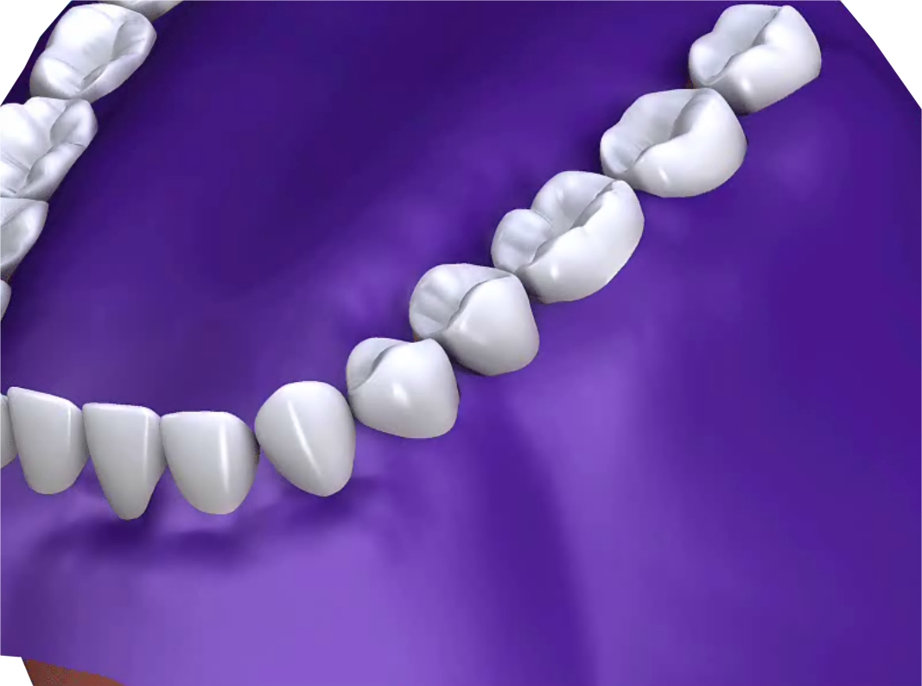
Q What is a Rubber Dam?

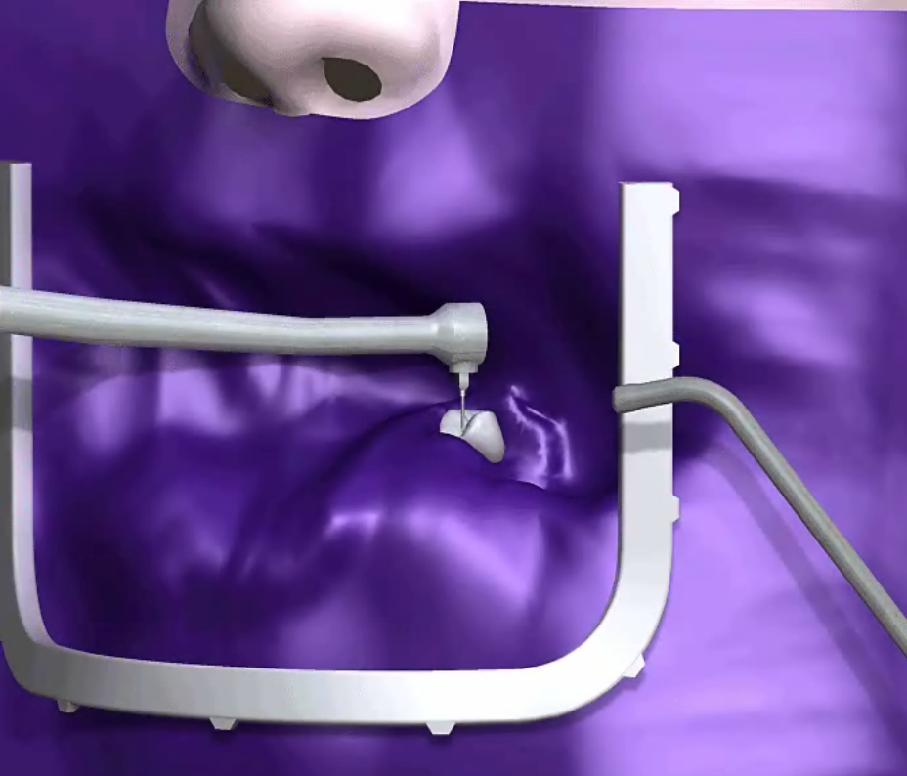
A A rubber dam is a thin protective sheet of rubber. It has either one hole or multiple holes through which the teeth will protrude. The teeth can then be worked on whilst the surrounding gums and mouth are protected.

Q When is a Rubber Dam needed?

A A rubber dam can be used for instance with a number of holes in it to expose the teeth and protect the gums during the tooth whitening process. Or a rubber dam can be used with a single hole to protect a tooth from contamination when carrying out
root canal treatment. It is also useful when white fillings are placed to keep the saliva away.

Q How is it used?

A Your dentist will place the protective dam on at the start of treatment. The dam will only be in place whilst treatment is in process. No discomfort should be experienced wearing the dam. In fact many people prefer their dental treatment with the rubber dam on.

Q What if I am allergic to rubber?

A Your dentist can use a non-latex sheet instead.

